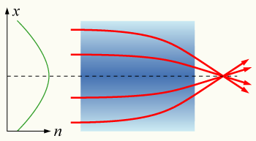

A gradient-index lens with a parabolic variation of refractive index (n) with radial distance (x). The lens focusses light in the same way as a conventional lens.

This bending effect is exploited in a gradient-index (GRIN) lens. This is a device with a radially-decreasing refractive index (usually a parabolically shaped index profile). A slab of this material acts like a conventional converging lens, but does not need to be shaped like one, simplifying the mounting of the lens. GRIN lenses are commonly used where many very small lenses are needed to be mounted together, such as in photocopiers and scanners.

Certain optical fibres (gradient- or graded-index fibres) are also made with a radially-varying refractive index profile; this design strongly reduces the modal dispersion of a multi-mode optical fibre.

The lens of a human eye also uses a radially-decreasing index gradient, as well as its shape, to focus light.

One of the most important advantages of GRIN lenses compared to classical lenses is that the optical surfaces of GRIN lenses are flat. This fact is very important for creating a good quality joint between lens and, for example, optical fiber.

The most popular production method of the glass-made GRIN lens is ion exchange. For example, a glass sample with Na+ ions could be immersed into liquid melt with Li+ ions. As a result of diffusion, Na would be partially exchanged with Li, with a larger amount of exchange occurring at the edge. Thus the sample obtains a gradient material structure and a corresponding gradient of the refractive index.

