Introduction Fiber Optic Spectroscopy
Optical spectroscopy is a technique for measuring light intensity in the UV-, VIS-, NIR- and IR-region. Spectroscopic measurements are being used in many different applications, such as color measurement, concentration determination of chemical components or electromagnetic radiation analysis. For more elaborate application information and setups, please see further the Application link.
A spectroscopic instrument generally consists of entrance slit, collimator, a dispersive element, such as a grating or prism, focusing optics and detector. In a monochromator system there is normally also an exit slit, and only a narrow portion of the spectrum is projected on a one-element detector. In monochromators the entrance and exit slits are in a fixed position and can be changed in width. Rotating the grating scans the spectrum.
Development of micro-electronics during the 90’s in the field of multi-element optical detectors, such as Charged Coupled Devices (CCD) Arrays and Photo Diode (PD) Arrays, enabled the production of low cost scanners, CCD cameras etc. The same CCD and PDA detectors are now used in the Avantes line of spectrometers, enabling fast scanning of the spectrum, without the need of a moving grating.
Thanks to the need for fiber optics in the communication technology, low absorption silica fibers have been developed. Similar fibers can be used as measurement fibers to transport light from the sample to the optical bench of the spectrometer. The easy coupling of fibers allows a modular build-up of a system that consists of light source, sampling accessories and fiber optic spectrometer.

Advantages of fiber optic spectroscopy are the modularity and flexibility of the system. The speed of measurement allows in-line analysis, and the use of low-cost commonly used detectors enable a complete low cost Avantes spectrometer system.
How to configure a spectrometer for your application.
In the modular AvaSpec design you have a number of choices to be made on the several optical components and options, depending on the application you want to use the spectrometer for.
This section should give you some guidance on how to choose the right grating, slit, detector and other options, installed in the AvaSpec.
- Wavelength Range
In the determination for the optimal configuration of a spectrometer system the wavelength range is first important parameter that defines the grating choice. If you are looking for a wide wavelength range, we recommend to take an A-type (300 lines/mm) or B-type (600 lines/mm) grating (see the "Grating selection table" in the technical details of the spectrometer product). The other important component is the detector choice, Avantes offers 4-7 different detector types with each different sensitivity curves (see figure 5). For UV applications the 256/1024 pixel CMOS detectors or DUV- enhanced 2048 or 3648 pixel CCD detector may be selected.
For the NIR range 2 different InGaAs detectors are available.
If you want to combine a wide range with a high resolution, a multiple channel spectrometer may be the best choice.
- Optical Resolution
If you desire a high optical resolution we recommend to pick a grating that has 1200 or more lines/mm (C,D,E or F types) in combination with a small slit and a detector with 2048 or 3648 pixels, for example 10 µm slit for the best resolution on the AvaSpec-2048 (see the "Resolution table" in the technical details of the spectrometer product)
- Sensitivity
Talking about sensitivity, it is very important to distinguish between photometric sensitivity (How much light do I need for a detectable signal?) and chemometric sensitivity (What absorbance difference level can still be detected?)
  - Photometric Sensitivity
In order to achieve the most sensitive spectrometer in for example Fluorescence or Raman applications we recommend the 2048 pixel CCD detector, as in the AvaSpec-2048. Further we recommend the use of a DCL-UV/VIS detector collection lens, a relatively large slit (100µm or higher) or no slit and an A type grating. For an A-type grating (300 lines/mm) the light dispersion is minimal, so it has the most sensitivity of the grating types. Optionally the Thermo-electric cooling of the CCD detector (see product section AvaSpec-2048-TEC) may be chosen to minimize noise and increase dynamic range at long integration times (60 seconds).
For the different detector types the photometric sensitivity is given in this table: Table Detector Specifications, the spectral sensitivity for each detector is depicted in figure 5.
  - Chemometric Sensitivity
To detect 2 absorbance values, close to each other with maximum sensitivity you need a high Signal to Noise (S/N) performance. The detector with best S/N performance is the 256/1024 CMOS detector in the AvaSpec-256/1024. The S/N performance can also be enhanced by averaging over multiple spectra.

4. Timing and Speed
The data capture process is inherently fast with detector arrays and no moving parts. However there is an optimal detector for each application. For fast response applications, we recommend to use the AvaSpec-2048 FT or USB2 spectrometer (see AvaSpec-2048 FT product section). When datatransfer time is critical awe recommend to select a small amount of pixels to be transferred with the new USB2 interface. Data transfer time can be enhanced by selecting the pixel range of interest to be transmitted to the PC; in general the AvaSpec-102 may be considered as the fastest spectrometer with more than 6000 scans per second.
The above parameters are the most important in choosing the right spectrometer configuration, please contact our application engineers to optimize and fine-tune the system to your needs. Below is a quick reference table 1 for most common applications, for a more elaborate explanation and configurations, please see section applications on this site.

In addition we have introduced application icons, that will help you to find the right products and accessories for your applications.

Sensitivity
The sensitivity of a detector pixel at a certain wavelength is defined as the detector electrical output per unit of radiation energy (photons) incident to that pixel. With a given A/D converter this can be expressed as the number of counts per mJ of incident radiation. The relation between light energy entering the optical bench and the amount hitting a single detector pixel depends on the optical bench configuration.  The efficiency curve of the grating used, the size of the input fiber or slit, the mirror performance and the use of a Detector Collection Lens are the main parameters. With a given set-up it is possible to do measurements over about 6-7 decades of irradiance levels. Some standard detector specifications can be found in table detector specifications (link below). Optionally a DCL cylindrical detector collection lens can be mounted directly on the detector array. The quartz lens (DCL-UV for AvaSpec-2048/3648) will increase the system sensitivity by a factor of 3-5, depending on the fiber diameter used. | 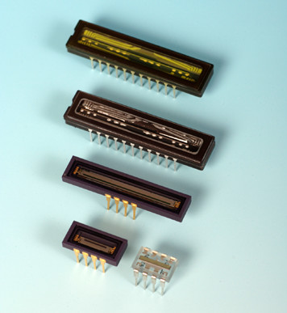
In the Table detector specifications the overall sensitivity is given for the detector types currently used in the AvaSpec spectrometers as output in counts per ms integration time.
To compare the different detector arrays we have assumed an optical bench with 600 lines/mm grating and no DCL. The entrance of the bench is an 8 µm core diameter fiber, connected to a standard AvaLight-HAL halogen light source. This is equivalent to ca. 1µWatt light energy input.
NIR detector specifications can be found in the AvaSpec-NIR256 product information technical data.
Table. Detector specifications.
Detector | TAOS 102 | HAM256 | HAM1024 | SONY2048 | Toshiba3648
Type | Photo diode array | CMOS linear array | CMOS linear array | CCD linear array | CCD linear array
# Pixels, pitch | 102, 85 µm | 256, 25 µm | 1024, 25 µm | 2048, 14 µm | 3648, 8 µm
pixel width/height | 77 x 85 µm | 25 x 500 µm | 25 x 500 µm | 14 x 56 µm | 8 x 200 µm
Sensitivity | 100 V/lx.s | 22 V/lx.s | 22 V/lx.s | 240 V/lx.s | 160 V/lx.s
Sensitivity  (AvaLight-HAL, 8 µm fiber) in counts per ms integration time | 1000 counts/µW (AvaSpec-102) | 30 counts/µW (AvaSpec-256) | 30 counts/µW (AvaSpec-1024) | 5000 counts/µW (AvaSpec-2048) | 12000 counts/µW (AvaSpec-3648)
Peak wavelength | 750 nm | 500 nm | 500 nm | 500 nm | 550 nm
Signal/Noise | 1000:1 | 2000 :1 | 2000 :1 | 250 :1 | 300:1
Dark noise | Ca. 15 counts | Ca. 7 counts | Ca. 11 counts | Ca. 10 counts | Ca. 10 counts
PNRU**(max.) | ± 10% | ± 3% | ± 3% | ± 5% | ± 5%
Wavelength range | 360-1100 nm | 200-1000 nm | 200-1000 nm | 200*-1100 nm | 200*-1100 nm
Frequency | 2 MHz | 500 kHz | 500 kHz | 2 MHz | 1 MHz
* DUV coated
** Photo Respons Non-Uniformity = max difference between output of pixels when uniformly illuminated, devided by average signal
Table 1. Quick reference guide for spectrometer configuration
Application | AvaSpec-type | Grating | WL range (nm) | Coating | Slit | FWHM Resolution (nm) | DCL | OSF | OSC
Biomedical | 2048 | NB | 500-1000 | - | 50 | 1.2 | - | 475 | -
Chemometry | 1024 | UA | 200-1100 | - | 50 | 2.0 | - | - | 200-1100
Color | 102 | VA | 360-780 | - | 100 | 6.4 | X/- | - | -
Color | 256 | VA | 360-780 | - | 50 | 3.2 | - | - | -
Color | 2048 | BB | 360-780 | - | 200 | 4.1 | X/- | - | -
Fluorescence | 2048 | VA | 350-1100 | - | 200 | 8.0 | X | - | 350-1100
Fruit-sugar | 102 | IA | 800-1100 | - | 50 | 5.4 | X | 550 | -
Gemmology | 2048 | VA | 350-1100 | - | 25 | 1.4 | X | - | 350-1100
High resolution | 2048 | VD | 600-700 | - | 10 | 0.07 | - | 550 | -
High resolution | 3648 | VD | 600-700 | - | 10 | 0.05 | - | 550 | -
Irradiance | 2048 | UA | 200-1100 | UV | 50 | 2.8 | X/- | - | 200-1100
Laserdiode | 2048 | NC | 700-800 | - | 10 | 0.1 | - | 550 | -
LED | 2048 | VA | 350-1100 | - | 25 | 1.4 | X/- | - | 350-1100
LIBS | 2048FT | UE | 200-300 | DUV | 10 | 0.09 | - | - | -
LIBS | 2048USB2 | UE | 200-300 | DUV | 10 | 0.09 | - | - | -
LIBS | 3648USB2 | UE | 200-300 | VUV | 10 | 0.07 | - | - | -
Raman | 2048TEC | NC | 780-930 | - | 25 | 0.2 | X | 550 | -
Thin Films | 2048 | UA | 200-1100 | UV | - | 4.1 | X | - | 200-1100
UV/VIS/NIR | 2048 | UA | 200-1100 | UV | 25 | 1.4 | X/- | - | 200-1100
NIR | NIR256-1.7 | NIRA | 1000-1700 | - | 50 | 5.0 | - | 1000 | -
NIR | NIR256-2.2 | NIRZ | 1000-2200 | - | 50 | 10.0 | - | 1000 | -

Optical Bench
The heart of the new AvaSpec series fiber optic spectrometer are 2 optical benches with 45 and 75 mm focal length, developed in a symmetrical Czerny-Turner design.
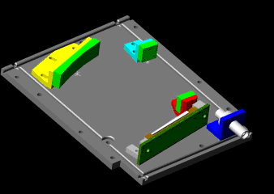
Light enters the optical bench through a standard SMA905 connector and is collimated by a spherical mirror. A plane grating diffracts the collimated light; a second spherical mirror focuses the resulting diffracted light. An image of the spectrum is projected onto a 1-dimensional linear detector array.
The optical bench has a number of components installed inside, allowing a wide variety of different configurations, depending on the intended application. The choice of these components such as the diffraction grating, entrance slit, order sorting filter and detector coating have a strong influence on system specifications. Sensitivity, resolution, bandwidth and stray light are further discussed in the following paragraphs.

How to choose the right Grating?

A diffraction grating is an optical element that separates incident polychromatic radiation into its constituent wavelengths. A grating consists of series of equally spaced parallel grooves formed in a reflective coating deposited on a suitable substrate. | 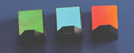
The way in which the grooves are formed separates gratings in two types, holographic and ruled. The ruled gratings are physically formed into a reflective surface with a diamond on a ruling machine. Gratings produced from laser constructed interference patterns and a photolithographic process are known as holographic gratings.
The fiber optic spectrometer comes with a permanently installed grating that must be specified by the user. Further the user needs to indicate what wavelength range needs to reach the detector. Sometimes the specified usable range of a grating is larger than the range that can be projected on the detector. In order to cover a broader range, a dual or triple beam spectrometer can be chosen. Then master and slave(s) have different gratings. Similarly, a higher resolution over a wide range can be achieved by using a dual or triple spectrometer.
For each spectrometer type a grating selection table is shown in the spectrometer platform section. Spectrometer Platforms
The Technical Details link on the bottom of this page, illustrates how to read the grating selection table. The spectral range to select in the table depends on the starting wavelength of the grating and the number of lines/mm; the higher the wavelength, the bigger the dispersion and the smaller the range to select.
On the bottom of this page a link to the efficiency curves can be found.
When looking at the grating efficiency curves, please realize that the total system efficiency will be a combination of fiber transmission, grating and mirror efficiency, detector and coatings sensitivities.
The grating disperion curves are shown for the AvaSpec 2048.

Spectral Range and Gratings
This table illustrates how to read the grating selection table. The spectral range to select in the table depends on the starting wavelength of the grating and the number of lines/mm; the higher the wavelength, the bigger the dispersion and the smaller the range to select.
Example of spectral range and gratings:
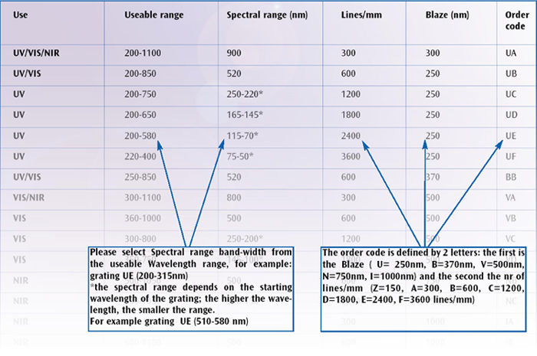

Grating Efficiency Curves
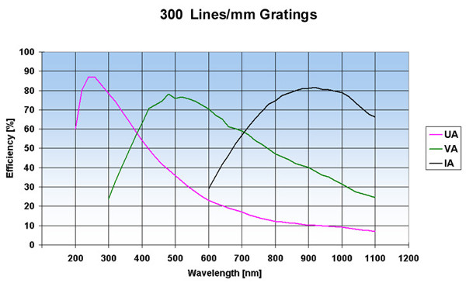
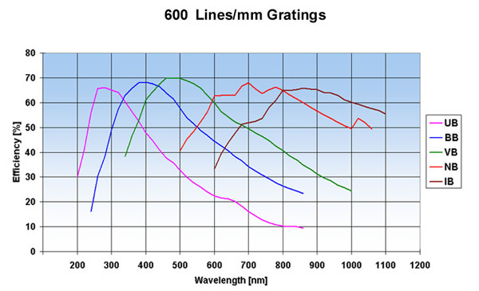
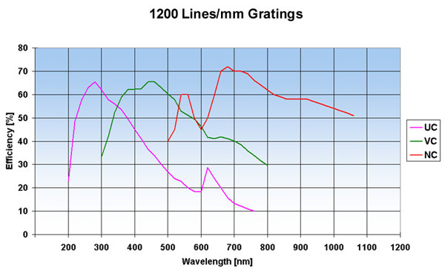
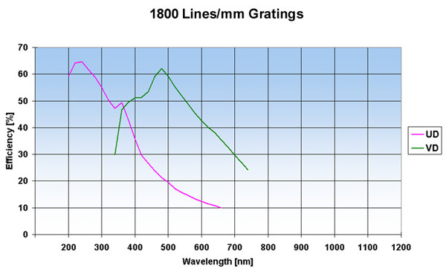
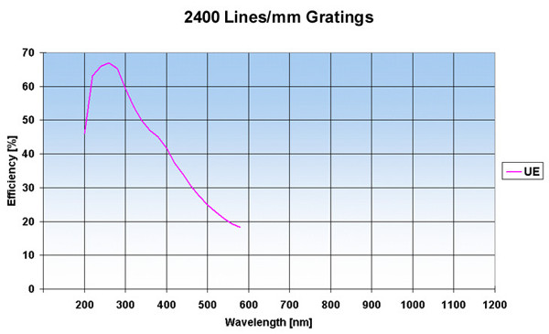
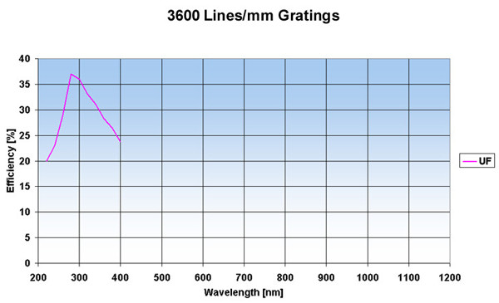

Grating Dispersion Curves
urves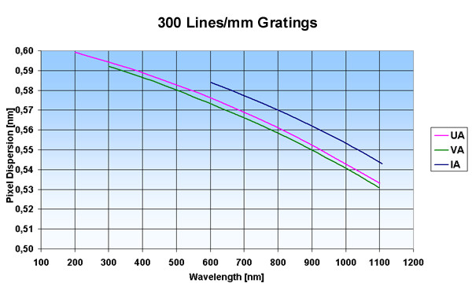
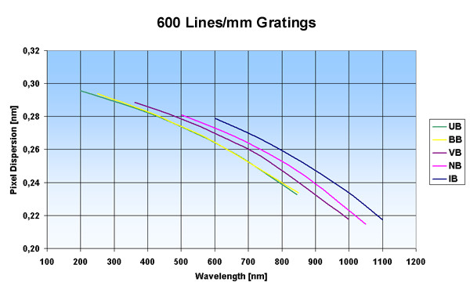

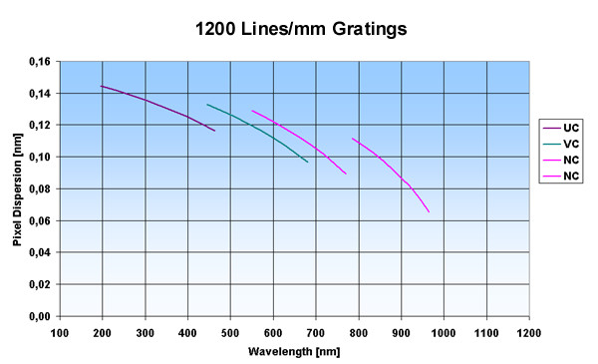
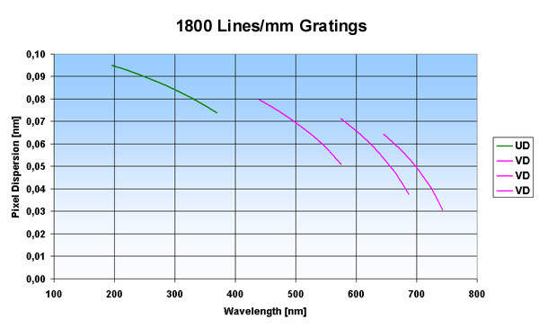

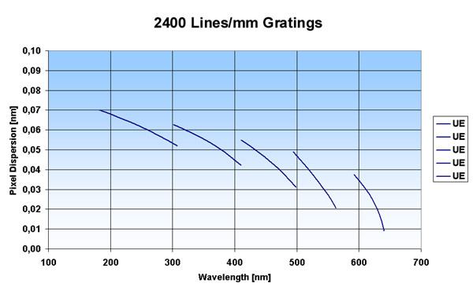
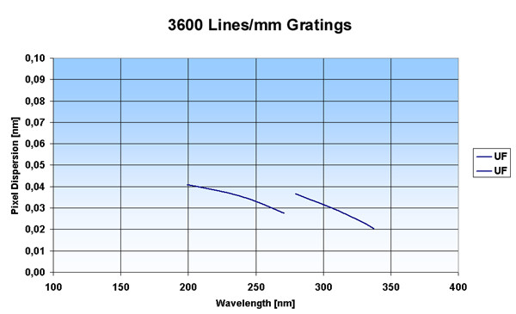

Detector Arrays
The AvaSpec spectrometers can be equipped with several types of detector arrays. Presently we offer silicon-based CCD, CMOS and Photo Diode Arrays for the 200-1100 nm range. A complete overview is given in the next section sensitivity in table detector specifications. For the NIR range (1000-2300nm) InGaAs arrays are implemented.

CCD Detectors (AvaSpec-2048/3648)
The Charged Coupled Device (CCD) detector stores the charge, dissipated as photons strike the photoactive surface. At the end of a controlled time-interval (integration time), the remaining charge is transferred to a buffer and then this signal is being transferred to the AD converter. CCD detectors are naturally integrating and therefore have enormous dynamic range, only limited by the dark (thermal) current and the speed of the AD converter.
The 3648 pixel CCD has an integrated electronic shutter function, so an integration time of 10µsec can be achieved.
+ Advantages for the CCD detector are many pixels (2048 or 3648), high sensitivity and high speed.
- Main disadvantage is the lower S/N ratio.

UV enhancement
For applications below 350 nm with the AvaSpec-2048/3648 a special DUV-detector coating is required. The uncoated CCD-response below 350 nm is very poor; the DUV lumogen coating enhances the detector response in the region 150-350nm. The DUV coating has a very fast decay time, typ. in ns range and is therefore useful for fast trigger LIBS applications.

Photo Diode Arrays (AvaSpec-102)
A silicon photodiode array consists of a linear array of multiple photo diode elements, for the AvaSpec-102 this is 102 pixels. Each pixel consists of a P/N junction with a positively doped P region and a negatively doped N region. When light enters the photodiode, electrons will become excited and output an electrical signal. Most photodiode arrays have an integrated signal processing circuit with readout/integration amplifier on the same chip.
+ Advantages for the Photodiode detector are high NIR sensitivity and high speed.
- Disadvantages are limited amount of pixels and no UV response.

CMOS linear image sensors (AvaSpec-256/1024)
These so called CMOS linear image sensors have a lower charge to voltage conversion efficiency than CCD array sensors and are therefore less light sensitive, but have a much better signal to noise ratio.
The CMOS detectors have a higher conversion gain than NMOS detectors and also have a clamp circuit added to the internal readout circuit to suppress noise to a low level.
+ Advantages for the CMOS detectors are good S/N ratio and good UV sensitivity.
- Disadvantages are the low readout speed en relative high cost (1024 pixels).

InGaAs linear image sensors (AvaSpec-NIR256)
The InGaAs linear image sensors deliver high sensitivity in the NIR wavelength range. The detector consists of a charge amplifier array with CMOS transistors, a shift register and timing generator. 2 versions of detectors are available:
· 256 pixel non-cooled InGaAs detector for the 1000-1700nm range
· 256 pixel 2-stage cooled Extended InGaAs detector for the 1000-2300nm range

Figure 5. Detector Spectral sensitivity curves
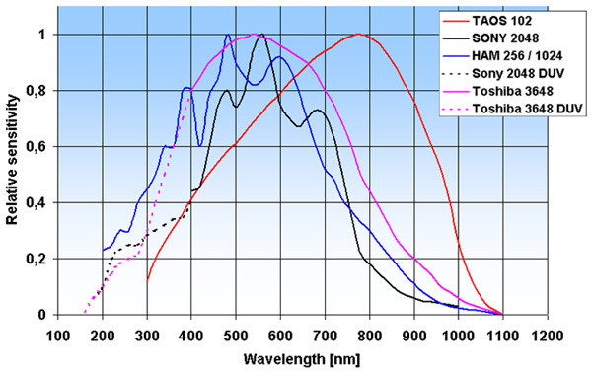

How to select optimal Optical Resolution
The optical resolution is defined as the minimum difference in wavelength that can be separated by the spectrometer. For separation of two spectral lines it is necessary to image them at least 2 array-pixels apart.
Because the grating determines how far different wavelengths are separated (dispersed) at the detector array, it is an important variable for the resolution. The other important parameter is the width of the light beam entering the spectrometer. This is basically the installed fixed entrance slit in the spectrometer, or the fiber core when no slit is installed.
The slits can be installed with following dimensions: 10, 25 or 50 x 1000 µm high or 100, 200 or 500 µm x 2000 µm high. Its image on the detector array for a given wavelength will cover a number of pixels. For two spectral lines to be separated, it is now necessary that they be dispersed over at least this image size plus one pixel. When large core fibers are used the resolution can be improved by a slit of smaller size than the fiber core. This effectively reduces the width of the entering light beam.
The influence of the chosen grating and the effective width of the light beam (fiber core or entrance slit) are shown in the tables at the product information.
In Table 3 (see link in the bottom of the page)the typical resolution can be found for the AvaSpec-2048. Please note that for the higher lines/mm gratings the pixel dispersion varies along the wavelength range and gets better towards the longer wavelengths (see also grating dispersion curves).
The resolution in this table is defined as F(ull) W(idth) H(alf) M(aximum), which is defined as the width in nm of the peak at 50% of the maximum intensity (see Figure below).
Graphs with information about the pixel dispersion can be found in the gratings section as well, so you can optimally determine the right grating and resolution for your specific application
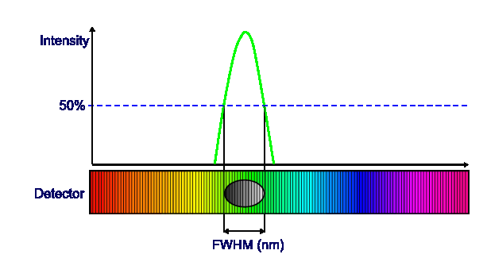

Optical Resolution
Resolution (FWHM in nm) for the AvaSpec-2048
Slit size (µm)
Grating (lines/mm) | 10 | 25 | 50 | 100 | 200 | 500
300 | 0.8 | 1.4 | 2.4 | 4.3 | 8.0 | 20.0
600 | 0.4 | 0.7 | 1.2 | 2.1 | 4.1 | 10.0
1200 | 0.1-0.2* | 0.2-0.3* | 0.4-0.6* | 0.7-1.0* | 1.4-2.0* | 3.3-4.8*
1800 | 0.07-0.12* | 0.12-0.21* | 0.2-0.36* | 0.4-0.7* | 0.7-1.4* | 1.7-3.3*
2400 | 0.05-0.09* | 0.08-0.15* | 0.14-0.25* | 0.3-0.5* | 0.5-0.9* | 1.2-2.2*
3600 | 0.04-0.06* | 0.07-0.10* | 0.11-0.16* | 0.2-0.3* | 0.4-0.6* | 0.9-1.4*

* depends on the starting wavelength of the grating; the higher the wavelength, the bigger the dispersion and the better the resolution

* depends on the starting wavelength of the grating; the higher the wavelength, the bigger the dispersion and the better the resolution

