Introduction Light Sources
Illumination light sources are needed for transmission, absorption and reflection spectroscopic setups. For the convenient coupling of the light into our range of fiber optic cables, bundles and probes, it is necessary that the light is collected and can be coupled through SMA-905 connectors. Avantes offers different light sources for the different applications and wavelength ranges, as can be seen in the table below.
Application | Wavelength Range | Type | Principle | Product
Color / VIS / NIR | 360-2000 nm | Tungsten Halogen | Continuous | AvaLight-HAL/HL-6000-S
DUV | 190-400 nm | Deuterium | Continuous | AvaLight-D-S-DUV
UV | 215-400 nm | Deuterium | Continuous | AvaLight-D-S
UV/VIS/NIR refl./abs. | 215-2000 nm | Deuterium/Halogen | Continuous | AvaLight-DH-S
UV/VIS/NIR absorption | 200-2000 nm | Deuterium/Halogen | Continuous | AvaLight-DHc
UV/VIS | 200-1000 nm | Xenon | Pulsed | AvaLight-XE
Fluorescence | Multiple possible | LED | Continuous | AvaLight-LED
Wavelength Calibration | 253-922 nm | Mercury-Argon | Continuous | AvaLight-CAL
Irradiance Calibration | 360-1100nm | Tungsten Halogen | Continuous | AvaLight-HAL-CAL
Irradiance Calibration | 200-1100nm | Deuterium/Halogen | Continuous | AvaLight-DH-CAL
Tungsten Halogen light sources are mostly used for the visible range to do color measurements. The halogen light source provides a very stable output and has a lifetime, depending on the color temperature of the bulb. The high stability of the halogen light sources enables the use as color reflection illumination source or as irradiance calibration light source. The most important feature of the halogen light is that the spectral output is smooth and monotonic without spikes or dips.
Deuterium light sources provide a stable output and are mostly used for UV absorption- or reflection-measurements. Also, the deuterium’s high stability enables the use as irradiance calibration source. The deuterium spectrum is not as smooth as the halogen spectrum and shows a high peak around 656 nm. A combination light source focusing the halogen through the deuterium produces a wide range light source.
Pulsed xenon light sources are mostly used in applications that require a long lifetime and where a stable output is not the highest demand. Also the spectral output of a xenon light source is not as continuous as a halogen or deuterium light source, it has some high peaks and valleys.
Whenever a high power small wavelength range illumination is needed an LED can efficiently be coupled into the fiber optics. A typical application is the use as an excitation light source for fluorescence applications. The long lifetime, short warm-up time and high stability are main features for LED light sources. The spectral distribution of the different light source is given in the figure below.

Spectral distribution of different light sources:
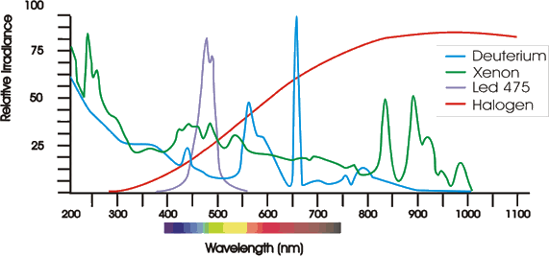
Avantes offers a source for wavelength calibration with a combination of mercury and argon spectral lines. All Avantes spectrometers are factory wavelength calibrated and do not need recalibration. The AvaLight-CAL can be used for recalibration purposes, AvaSoft offers an auto-calibration routine that supports the automatic recalculation of the wavelength calibration coefficients.

AvaLight-DHc Compact Deuterium and Halogen Light Source
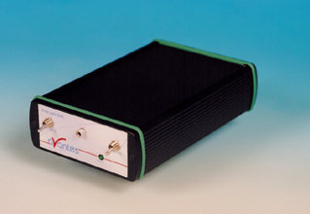
AvaLight-DHc Compact Deuterium and Halogen Light Source
The AvaLight-DHc is a combined deuterium-halogen light source, to be used for UV/VIS/NIR- applications. The output energy of the AvaLight-DHc is relatively low. The use is therefore recommended in transmission setup with large diameter fibers. The light source emits light from 200-1700 nm and has an SMA connector to easily couple into our fiber optic probe range. The AvaLight-DHc has an integrated TTL shutter, that can be used for auto-save dark / lamp off in combination with AvaSoft (extra IC-DB15-2 or IC-DB26-2 needed). Optionally, the AvaLight-DHc can be delivered in Rackmounted version, to be fully integrated in the 19” rackmount or 9.5” desktop housing.
A direct attach cuvette holder CUV-DHc (see section accessories) is available for fluorescence or absorbance measurements.
When ordering a CUV-DHc, Cuvette holder as direct attachment for an AvaLight-DHc, a modification needs to be done on the AvaLight-DHc front panel.
Therefore the AvaLight-DHc needs to be returned to Avantes.
When ordering an AvaLight-DHc and CUV-DHc together this modification will be done directly.

Technical Details

 | Deuterium Light Source | Halogen Light Source
Wavelength Range | 200 - 400 nm | 400 - 2000 nm
Stability | < 1mAU | < 1mAU
Warm-up time | 8 min | 1 min
Drift | < 0.25% / h | < 0.25% / h
Optical Power in 600 µm fiber | 0.2 µWatt | 7 µWatt
Lamp Lifetime | 1000 hours | 2000 hours
Temp. Range | 5°C - 35°C
Power Supply | 12VDC / 450mA
Dimensions | 175 x 110 x 44 mm

Spectral output of AvaLight-DHc:
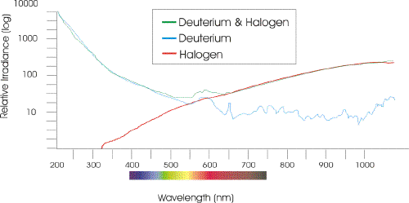

AvaLight-D(H)-S Deuterium-Halogen Light Source
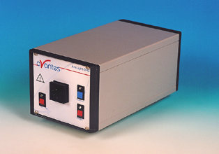
AvaLight-DH-S Deuterium-Halogen Light Source
The AvaLight-DH-S is a combined Deuterium and halogen light source, which can be used for UV/VIS/NIR applications. The AvaLight-DH-S has a SMA905 connector to be used with fiber optic cables and bundles. For optimal coupling an adjustable focus lens assembly is included. The light source supplies a continuous spectrum with high efficiency and highest stability in the UV, visible and near-infrared range from 215-2000 nm.
The Avalight-DH-S was developed based on the shine-through principle, in which the halogen light is focused through a small diameter aperture in the deuterium bulb.
For UV only applications the AvaLight-D-S source (only Deuterium) is available.
The standard AvaLight-D(H)-S light sources have a special UV longpass filter (>220nm) implemented to protect the fibers from solarizing. For applications that require a spectral range below 220 nm a Deep UV bulb is available, in which no UV longpass filter is included. For these Deep-UV measurements (from 190nm) the AvaLight-D(H)-S-DUV may be ordered.
For all Deuterium Light Sources solarization resistant fibers (-SR) are recommended, for the DUV lamp special solarization resistant fibers (-SR) are required (see the fiber optic section of this website).
The output of the AvaLight-DH-S is optimized for fibers(bundles) with a diameter up to 600 µm, for larger diameter fiber bundles the AvaLight-DH-S SMA connector focal point can be manually adapted to uniformly fill a larger core diameter fiber cable or bundels.
In all AvaLight-Deuterium sources an integrated TTL-shutter and filter holder for filters of up to 50x50x6.5 mm are implemented.
The Avalight-DH-S internal TTL shutter can be controlled from the AvaSpec, so the auto-save dark option in the AvaSoft software can be used (extra IC-DB15-2 or IC-DB26-2 needed).
The filter holder can be easily replaced by a direct attach cuvette holder CUV-DHS (see section accessories) useful for fluorescence or absorbance measurements.

Technical Details

 | Deep UV Deuterium | Deuterium Lamp | Halogen Lamp
Wavelength Range | 190-400nm | 215-400nm |  | 360-2000nm
Warm-up Time | 30 min. | 30 min. |  | 20 min.
Lamp Power | 78W / 0.75A | 78W / 0.75A |  | 5W /0.5A
Lamp Lifetime | 1000 hrs | 1000 hrs |  | 1000 hrs
Stability | 0,1% | 0,1% |  | 0,4%
Color Temperature | - | - |  | 3000 K
Optical Power in 200μm fiber | 11 μW | 7 μW |  | 43 μW
Optical Power in 600μm fiber | 72 μW | 61 μW |  | 239 μW
Optical Power in 1000μm fiber | 206 μW | 166 μW |  | 354 μW
Power consumption | 90 Watt (190Watt for heating D-Lamp 4-5 sec.)
Power Requirements | 100-240VAC 50/60 Hz
Dimensions / Weight | 315 x 165 x 140 mm / ca 5 kg.

Spectral output AvaLight-DS
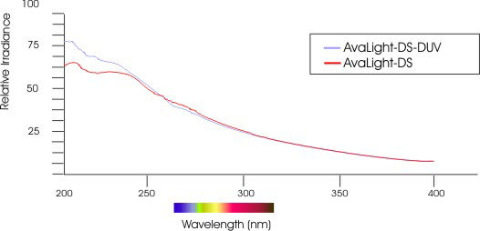
Spectral output AvaLight-DHS
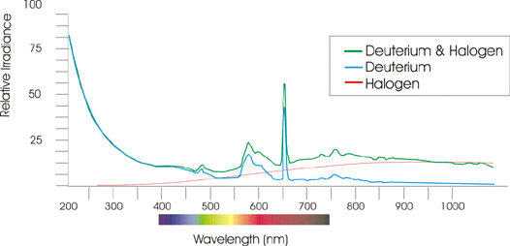

Seperate 50x50mm filters to install in AvaLight-D(H)-S
GL-WG305-3 | Separate 50 x 50 x 3 mm long-pass filter > 305 nm
GL-KG3-3 | Separate 50 x 50 x 3 mm bandpass filter, transparent > 325 nm and < 700 nm
GL-BG28-3 | Separate 50 x 50 x 3 mm bandpass filter, transparent > 360 nm and < 500 nm
GL-GG385-3 | Separate 50 x 50 x 3 mm long-pass filter > 385 nm
GL-GG475-3 | Separate 50 x 50 x 3 mm long-pass filter > 475 nm
GL-OG515 -3 | Separate 50 x 50 x 3 mm long-pass filter > 515 nm
GL-OG550-3 | Separate 50 x 50 x 3 mm long-pass filter > 550 nm
GL-OG590-3 | Separate 50 x 50 x 3 mm long-pass filter > 590 nm
GL-NG9-1 | Separate 50 x 50 x 1 mm Neutral Density filter
GL-NG9-2 | Separate 50 x 50 x 2 mm Neutral Density filter
GL-NG9-3 | Separate 50 x 50 x 3 mm Neutral Density filter
more filter types available, please contact us for ordering information.

