Introduction Fiber Optics
The use of fiber optics as light guidance allows a great modularity and flexibility in the setup of an optical measurement system. Optical fibers can be made of many materials, such as plastic, glasses and silicates (SiO2). For high quality fiber optics, as used in spectroscopic applications, synthetic fused silica (amorphous silicon dioxide) is used, that can be intentionally doped with trace elements to adjust the optical properties of the glass.
The basic principle of light transport through an optical fiber is total internal reflection. This means that the light within the numerical aperture of a fiber (NA = input acceptance cone) will be reflected and transported through the fiber. The size of the numerical aperture depends on the materials used for core and cladding.
Two basic types of silica fibers can be distinguished; singlemode and multi-mode fibers, depending on the propagation state of the light, traveling down the fiber. For most spectroscopic applications multi-mode fibers are used. Multi-mode fibers can be divided into 2 subcategories, step-index and graded-index. A relatively large core and high NA allow light to be easily coupled into the fiber, which allows the use of relatively inexpensive termination techniques. Step-index fibers are mainly used in spectroscopic applications.
Graded-index multimode fibers have a refractive index gradually decreasing from the core out through the cladding. Since the light travels faster in material with lower refractive index, the modal dispersion (amount of pulse-spreading) will be less. These graded-index fibers are mainly used in telecommunication application, where bandwidth at long distance (2-15 km) plays an important role.
In the following paragraphs some basic fiber optic components and properties will be discussed.

Solarization Resistant Fibers for Deep UV applications
Most spectroscopic applications with fiber optics have been restricted to wavelength ranges above 230 nm, because standard silica fibers with an undoped core and fluorine doped cladding are frequently damaged by exposure to deep-UV light (below 230 nm). This solarization effect is induced by the formation of "color centers" with an absorbance band of 214 nm. These color centers are formed when impurities (like Cl) exist in the core fiber material and form unbound electron pairs on the Si atom, which are affected by the deep UV radiation.
Not long ago, solarization resistant fibers, which were hydrogen loaded, were developed (UVI). The disadvantage for these fibers is the limitation on smaller fiber diameters and limited lifetime, caused by the H2 outgassing from the fiber. Recently, with the availability of a modified core preform, a new fiber became available (UVM). This fiber provides longterm stability at 30-40 % transmission (for 215 nm)
All fiber optic probes, cables and bundles with core diameters of 100 µm, 200 µm, 400 µm and 600 µm can be delivered with solarization resistant fibers. All assemblies, made by us, are pre-solarized for an 8-hrs period, to have a constant transmission of 30-40% @ 215 nm.
Solarization standard UV400 fiber
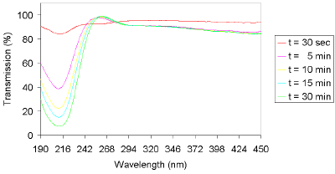
Solarization UV100-SR fiber
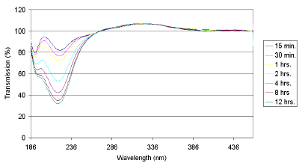
Solarization UV100-SR fiber
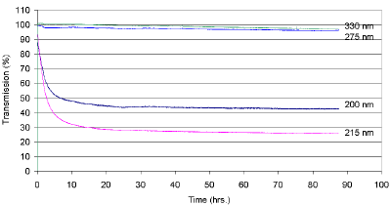

Ordering Information
-SR | solarization resistant fiber for DUV applications

Fiber Optic Probe Properties
Thermal resistance
The thermal resistance of a fiber optic assembly depends on some of the materials used:
- Fiber, the standard fiber design has a polyimide buffer, covering a wide thermal range –190 to 400 °C. For higher temperatures aluminum coated (to 500°C) or gold coated (to 750°C) fibers are recommended.
- Sleeving, the standard sleeving is PVC based and has a small temperature range (-20°C to 65°C), for higher temperatures a flexible metal sleeving (-ME) with silicone inner tubing is recommended (up to 250°C) or stainless steel tubing (not flexible, to 750°C).
- Probe ends, connectors and ferrules are standard made of metal and have a wide temperature range. For special plastics, like PVC, PEEK and Teflon a limited temperature range is applicable.
- Bonding epoxy, the standard epoxy used is a heat curing bonding epoxy with a temperature range of –60°C to 175°C. The curing temperature is standard 100 °C, for high temperature ranges (order code -HT), the curing temperature is 200°C. Sometimes UV-curing epoxies are used
Technical Data
Temperature range | Fiber | Sleeving | Probe end | Epoxy
–20°C to +65°C | standard Polyimide | Standard PVC | Standard metal/ PVC/PEEK/PTFE | Standard
-30°C to +100°C | standard Polyimide | Metal (-ME) or silicone (-MS) | Standard metal/ PEEK/PTFE | Standard
-60°C to 200°C (HT) | standard Polyimide | Metal (-ME) or silicone (-MS) | Standard metal/ PEEK/PTFE | High temperature curing epoxy
-60°C to 400°C | standard Polyimide | Metal (-ME) or SS-tubing | metal | Special polyimide epoxy or ceramic
-60°C to 500°C | Aluminum coated | SS-tubing or none | metal | Direct bonding
-60°C to 750°C | Gold coated | SS-tubing or none | metal | Direct bonding

Chemical resistance
The chemical resistance of a fiber optic assembly depends on some of the materials used:
- Fiber, the standard fiber design has a polyimide buffer, which normally will not be in contact with the sample; the quartz core provides good resistance against most solvents.
- Sleeving, the standard sleeving is PVC based and has a relative good chemical resistance. The –ME chrome plated brass sleeving also has a good chemical resistance, but is not waterproof. The Silicone metal sleeving (-MS) is recommended for waterproof environment, biomedical applications, etc. The PEEK and PTFE sleeving have the best chemical resistance.
- Probe ends, connectors and ferrules are standard made of stainless steel and are not very well suitable in corrosive environment. For most corrosive environments PEEK, PTFE or Hastelloy® are recommended.
- Bonding epoxy, the standard epoxy used is resistant to water, inorganic acids and salts, alkalis and many aggressive organic solvents and most petrochemical products and an extended range of organic and inorganic environments.
The table below gives a good summary for the chemical resistance for most materials used.
The table has been drawn up on the basis of relevant sources in accordance with the state of the art; no claim to completeness. The data constitutes recommendations only, for which no liability can be accepted.
Please contact us if you have any doubt about the materials to use for your application.
Technical Data
Chemical environment | Fiber |  | Sleeving |  | Probe end |  | Epoxy
Acids weak | standard Polyimide | ± | -ME  -MS  -PEEK  -PVC | ±  +  +  + | St. steel  PEEK  PTFE  Hastelloy® | -  +  +  + | +
Acids strong | standard Polyimide | - | -ME  -MS  -PEEK  -PVC | -  ±  +  ± | St. steel  PEEK  PTFE Hastelloy® | -  +  +  + | ±
Bases weak | standard Polyimide | ± | -ME  -MS  -PEEK  -PVC | +  +  +  + | St. steel  PEEK  PTFE  Hastelloy® | +  +  +  + | +
Bases strong | standard Polyimide | - | -ME  -MS  -PEEK  -PVC | +  +  +  + | St. steel  PEEK  PTFE  Hastelloy® | +  +  +  + | +
Aromatic carbons | standard Polyimide | + | -ME  -MS  -PEEK  -PVC | +  +  +  + | St. steel  PEEK  PTFE  Hastelloy® | +  +  +  + | +
Alcohols | standard Polyimide | ± | -ME  -MS  -PEEK  -PVC | +  ±  +  + | St. steel  PEEK  PTFE  Hastelloy® | +  +  +  + | +
Ketons/Ethers | standard Polyimide | + | -ME  -MS  -PEEK  -PVC | +  -  +  - | St. steel  PEEK  PTFE  Hastelloy® | +  +  +  ± | ±
+ = good resistance
± = conditional resistant
- = not resistant

Fiber Optic Design
Core
For spectroscopic applications, generally, multi-mode step index silica fibers are used. These range in core thickness from 50 microns to 1 mm. The core is made out of pure silica. Other fiber cores with much higher absorption are made out of certain glass types or plastics. These are not offered in this catalog.
First a distinction is made between silica with high or low OH content. Silica fibers with high OH (600-1000 PPM) are used in the UV/VIS wavelength range because of the low absorption in the UV. They are referred to as UV/VIS fibers. For Deep-UV applications (below 230 nm) special solarization resistant fibers can be used.
The water content causes strong absorption peaks in the NIR wavelength range. In order to get good fibers for the NIR range, the “water” is removed from the silica. This results in low OH fibers (<2 PPM) with low absorption in the NIR. They are referred to as VIS/NIR fibers.

Cladding
In order to get the light guiding effect the core is cladded with a lower index of refraction material. For the highest quality fibers with the lowest absorption this is a fluorinedoped silica, the so-called silica-silica or all-silica fibers with a numerical aperture (NA) of 0.22.

Buffers
Without further protection fibers would easily break, because of small scratches or other irregularities on the surface. Therefore a next layer, the buffer, is added. This buffer also determines under what circumstances the fiber can be used. Temperature range, radiation, vacuum, chemical environment and bending are factors to be considered.
Polyimide buffers offer a wide temperature range (-100 to 400°C) and superior solvent resistance. Also, this material is non-flammable. Drawbacks are sensitivity to micro bending and the difficulty to remove it.
For extreme temperatures (-190 to 750°C) a gold buffer is used. Gold-coated fibers are virtually inert to all environments and make hermetically sealed high pressure feed through’s possible. (See: pressure feed through’s). The same is true for aluminum buffers for temperatures from -190 up to about 500°C. Low outgassing makes them also excellent for use in vacuum.

Technical Data fused silica fibers
Technical data fused silica fibers
Fiber type | Step index
Core Numerical Aperture | 0,22 ± 0,02
Buffer NA | Polyamide (1,78) strips cladding modes
Laser damage resistant core | 1,3 kW/mm2 CW at 1060 nm, up to 10 J, pulsed
Bend radius | momentary 100 x clad radius  long term 600 x clad radius
Mechanical Stress | Standard prooftest: 70 kpsi

Numerical Aperture | Fiber Optic Design
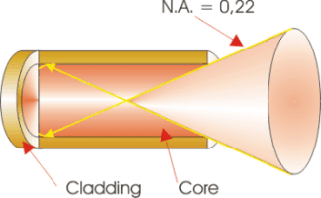 | 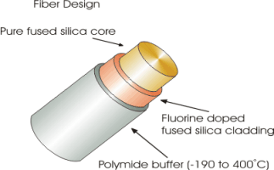

Transmission UV/VIS Fibers:
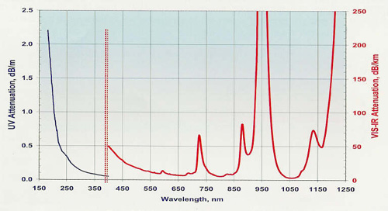
Transmission VIR/NIR Fibers:
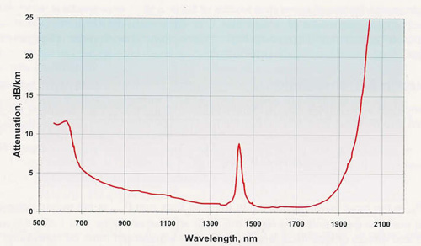

Fiber Optics Sleeves
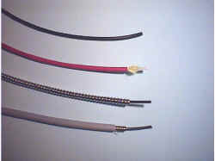
Fiber Optic sleeving material

For different applications Avantes offers different sleeving material. Standard our fiber optic cables and bifurcated cables are protected by a Kevlar reinforced polypropylene inner tubing with PVC red outer jacket. All of our standard reflection probes are protected by a flexible chrome-plated brass outer tube, with hooked profile for optimal strain relief with silicon or PTFE inner tubing. For waterproof and some medical applications stainless steel spiral tubing with glassilk and gray outer silicon rubber coating can be provided. Inside this tubing silicon or PTFE inner tubing is used as well. Especially for small, flexible, endoscopic probes we use a PVC rubber sleeving. Some specifics on the sleevings can be found in the following technical information.
Sleeve material | Kevlar reinforced PVC | Chrome plated brass | Silicon coated stainless steel | PVC
Inner Tubing | Polypropylene | Silicon/PTFE | Silicon/PTFE | n.a.
Outer dimensions | 3,8 mm | 5,0 mm | 5,8 mm | 2,0 mm
Temperature Range | -20°C to +65°C | -65°C to +250°C | -60°C to +180°C | -20°C to +65°C
Tensile Strength | 150 N | 350 N | 70 N | n.a.
Application | Standard | Heavy Industrial | Waterproof IP67 | Medical

Standard-Kevlar reinforced PVC | ME-Chrome plated brass
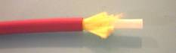 | 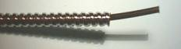
MS-Silicon coated stainless steel
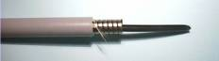

Fiber Optic Connectors
SMA connectors
Standard we supply all of our fiber optic cables, bundles and probes with SMA 905 connectors, that easily fit into our complete range of spectrometers, light sources and accessories. The SMA 905 connectors are screw-fitted and can be rotated over 360 degrees. The typical insertion loss for the connectors is 0,5 dB. The maximum filling diameter for bundles is 2,46 mm.
Standard SMA connector
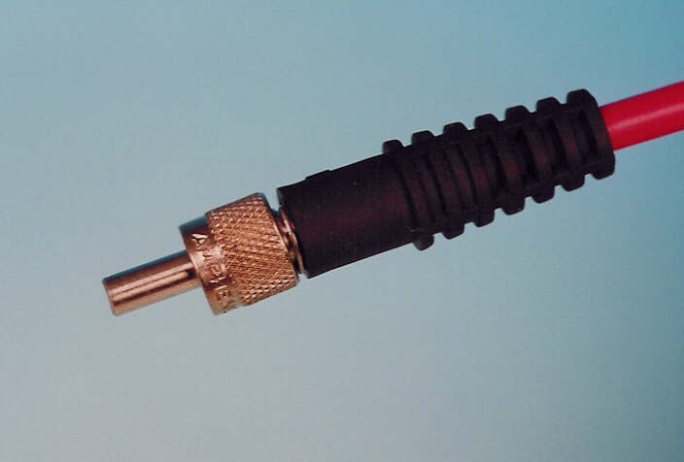
ST Connectors
For certain applications ST-connectors can be mounted to our fiber optic products as well. ST-connectors easily mount with their bayonet type of fitting, and can therefore not rotate, i.e. mount in a fixed position. The maximum filling diameter is 1,5 mm, typical insertion loss is 0,3 dB.
FC/PC connectors
Optional FC/PC-connectors can be mounted to our fiber optic products. The multimode FC/PC connectors have an extremely low insertion loss of < 0,2 dB. The FC/PC connector can not rotate, always mounts into the same fixed position and therefore has a high reproducibility.

Standard SMA |  | SMA with extended ferrule
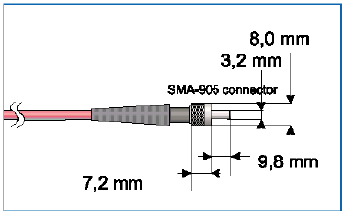 |  | 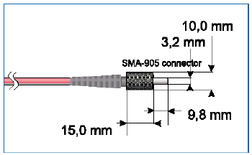
ST connectors |  | FC/PC connectors
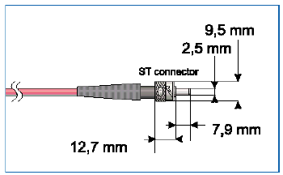 |  | 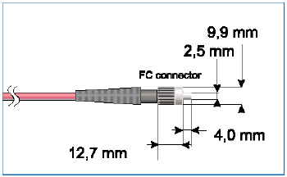

Reflection Probes (Standard)
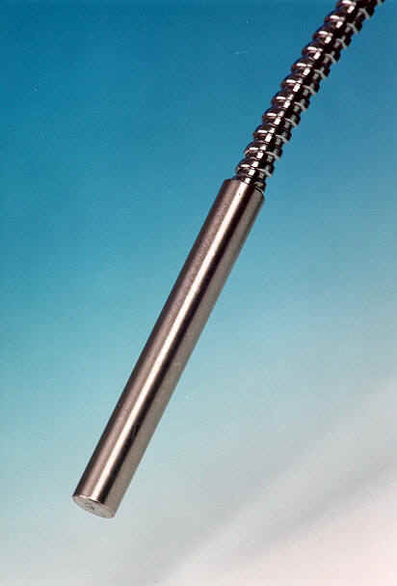
Standard Reflection Probe

The FCR-7xx200-2 is a standard reflection probe to get spectral information of diffuse or directly reflecting or back-scattering materials.
Via a standard SMA905 connector light from a light source is coupled into a fiber bundle, consisting of 6 fibers and carried to the probe end. The surface will selectively reflect light back into a 7th fiber. This fiber transfers the data to the output SMA905 connector, which can be coupled to a spectrometer or spectrum analyzer.
A higher number of fibers are possible to couple more energy from the light source and to increase the signal level.
For measurements under 90º the FCR-90-Option, a special adapter with a mirror under 45º, was developed, which can be easily mounted on the tip of the reflection probe.
The FCR-COL is available to focus the measurement spot on an extended distance.

Technical Details

Fibers | 7 or 19 fibers 200 μm or 400 μm core, 6 or 17 light-fibers, 1 or 2 read fiber, N.A.= 0,22. Standard 2m length, splitting point in the middle.
Wavelength range | 200-800 nm (UV/VIS) or 350-2000 (VIS/NIR)
Connectors | SMA905 connectors (2x)
Probe end | Stainless steel cylinder, 50 mm long x 6,35 mm diameter.
Tubing | The optical fibers are protected by a silicon inner tube and a flexible chrome plated brass outer tubing. The tubing also gives stress relieve. OD: 5.0 mm
Temperature | -30ºC to 100ºC. (High Temperature Probe FCR-7UV200-2-ME-HTX)
Bending | Minimum bend radius: Short term (few seconds) 20 mm, long term: 60 mm

